CYBERSECURITY INTERNSHIP

khushi Kumari

email: khushikumari40363636@gmail.com

INTERNSHIP TASK 01

create a python program that can encrypt or decrypt text using the Caesar cipher algorithm. Allow user to input a message and a shift value to perform encryption and decryption.

CODE:

def caesar_cipher(text, shift, mode='encrypt'):

result = ""

# Adjust the shift value for decryption

if mode == 'decrypt':

shift = -shift

# Loop through each character in the text

for char in text:

if char.isalpha(): # Check if the character is a letter

shift_base = 65 if char.isupper() else 97 # Determine ASCII base for uppercase/lowercase

# Shift the character and wrap around using modulo

result += chr((ord(char) - shift_base + shift) % 26 + shift_base)

else:

result += char # Non-alphabet characters remain the same

return result

def main():

# Get user input for message, shift value, and mode

mode = input("Do you want to encrypt or decrypt? (enter 'encrypt' or 'decrypt'): ").strip().lower()

message = input("Enter your message: ")

shift = int(input("Enter the shift value: "))

# Perform encryption or decryption

if mode in ['encrypt', 'decrypt']:

result = caesar_cipher(message, shift, mode)

print(f"The {mode}ed message is: {result}")

else:

print("Invalid mode selected. Please enter 'encrypt' or 'decrypt'.")

if __name__ == "__main__":

main()

SCREENSHOT:

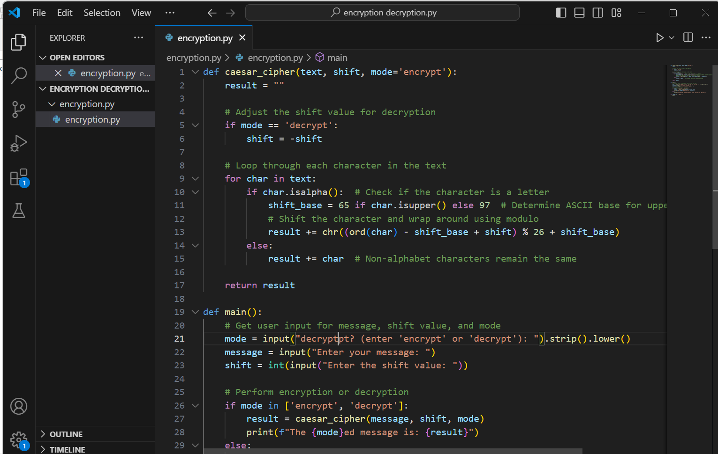

OUTPUT SCREENSHOT:

